Evaluate for Amazon Connect on the AWS Cloud

Quick Start Reference Deployment

November 2017

*Qualtrak Solutions Ltd*

*AWS Quick Start Reference Team*

Contents

Overview 2

Evaluate for Amazon Connect on AWS 2

Costs and Licenses 4

Architecture 4

Prerequisites 5

Specialized Knowledge 5

Technical Requirements 5

Deployment Options 5

Deployment Steps 6

Step 1. Prepare Your AWS Account 6

Step 2. Subscribe to the Evaluate for Amazon Connect AMI 6

Step 3. Launch the Quick Start 6

Step 4. Test the Deployment 10

Step 5. Enable Data Streaming 11

Step 6. Configure the integration 12

Best Practices Using Evaluate for Amazon Connect on AWS 12

FAQ 12

Additional Resources 14

Send Us Feedback 15

Document Revisions 15

This Quick Start deployment guide was created by Amazon Web Services (AWS) in partnership with *Qualtrak Solutions Ltd*.

[Quick Starts](http://aws.amazon.com/quickstart/) are automated reference deployments that use AWS CloudFormation templates to deploy key technologies on AWS, following AWS best practices.

## Overview

This Quick Start reference deployment guide provides step-by-step instructions for deploying **Evaluate for Amazon Connect** on the Amazon Web Services (AWS) Cloud.

This Quick Start is for IT infrastructure architects, administrators, and DevOps professionals who are planning to implement or extend their Tableau Server workloads to the AWS Cloud.

### Evaluate for Amazon Connect on AWS

**Evaluate for Amazon Connect** by Qualtrak Solutions is a high standard agent evaluation (Quality Monitoring) and online learning solution that will help you to develop the skills of your agents and achieve the required standards in customer service, customer loyalty, brand values adherence, cross and up-selling, first call resolution, optimum call handling time and much more. It is easy and intuitive to use and highly scalable.

Evaluate is seamlessly integrated directly to the Amazon Connect call recording service and uses the Contact Trace Records (CTR) to enable supervisors to find calls that contain the appropriate ‘situations’ which match precisely the agent’s personal performance improvement needs e.g. how well did the agent transfer the customer’s call to another agent; if the customer was placed on hold, did the agent return to the customer if the hold-time was greater than x seconds and apologize; if the call resulted in the agent placing the customer on hold more than y times, was this caused by the agent failing to gain an understanding of the customer’s needs and causing the length of the call to be longer than it needed to be, etc. For the supervisor to be able to coach their agents on personal needs, it requires the right calls to be found (using CTRs) which contain the appropriate ‘situations’. Evaluate does not require the use of a third-party call recorder and therefore avoids additional costs.

Typically, the cost of agents equates to around 55% of the total contact center costs. Being able to manage effectively the performance of agents and be able to maximize both the productivity and quality of customer interactions, requires a robust Quality Management program to be implemented which continuously measures agent performance, identifies individual improvement needs and delivers to the agents appropriate online learning/coaching. Evaluate provides supervisors and managers with the required tools to support their Quality program.

**Evaluate for Amazon Connect** delivers significant value by including the following key benefits:

* rate the quality of calls against defined standards and create performance metrics
* track the performance of agents and benchmark agent and team performance
* create ‘evaluation templates’ which include the required skills and knowledge to meet critical standards e.g. regulatory compliance, cross and up-selling and much more
* include weightings for each evaluation element (questions) in order to produce headline scores
* include ‘auto-fail’ and calibration of supervisors’ evaluation consistency and objectivity
* provide agent coaching feedback comments, supportive call segments and learning attachments to each individual question in order that evaluated calls can also provide continuous online learning
* use the available easy to use/preformatted reports to track performance and set goals

**Evaluate for Amazon Connect** is a multi-tenanted solution designed to be used by customers with multiple locations (of all sizes) using a common active directory. The solution is designed to be used by every type of user including supervisors, agents, homeworkers, branch network employees, quality and compliance auditors, trainers and managers/senior executives.

### Costs and Licenses

You are responsible for the cost of the AWS services used while running this Quick Start reference deployment. There is no additional cost for using the Quick Start.

The AWS CloudFormation template for this Quick Start includes configuration parameters that you can customize. Some of these settings, such as instance type, will affect the cost of deployment. For cost estimates, see the pricing pages for each AWS service you will be using. Prices are subject to change.

Each deployment gets a 30 days free trial. During this period, the customer will not be charged for the **Evaluate for Amazon Connect** software but will be charged for the use of the AWS services. After the 30 day free trial the customer will be charged in accordance with the listing price*.*

## Architecture

Deploying this Quick Start for a new virtual private cloud (VPC) with **default parameters** builds the following **Evaluate for Amazon Connect** environment in the AWS Cloud.

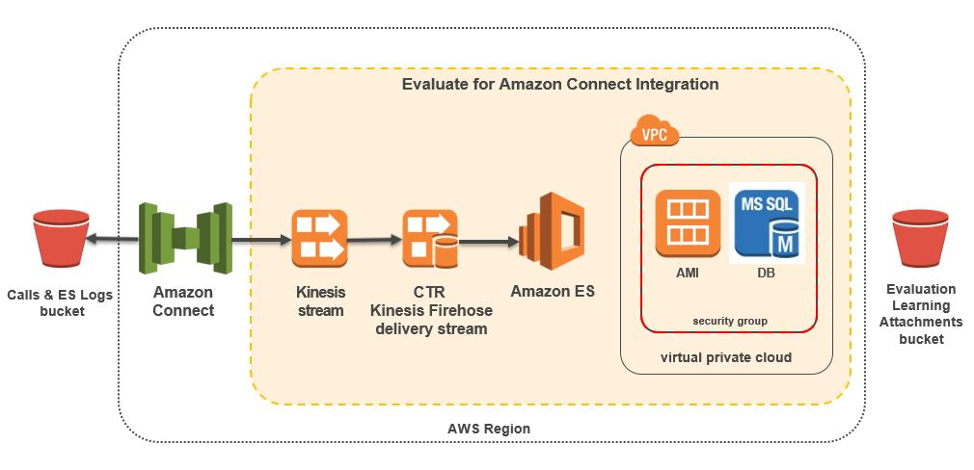

Figure 1: Quick Start Evaluate for Amazon Connect architecture on AWS

## Prerequisites

### Specialized Knowledge

Before you deploy this Quick Start, we recommend that you become familiar with the following AWS services. (If you are new to AWS, see [Getting Started with AWS](https://aws.amazon.com/getting-started/).)

* [Amazon VPC](https://aws.amazon.com/documentation/vpc/)
* [Amazon EC2](https://aws.amazon.com/documentation/ec2/)
* [Amazon S3](https://aws.amazon.com/documentation/s3/)
* [Amazon EBS](https://docs.aws.amazon.com/AWSEC2/latest/UserGuide/AmazonEBS.html)
* [Amazon ElasticSearch](https://aws.amazon.com/documentation/elasticsearch-service/)
* [Amazon Kinesis](https://aws.amazon.com/documentation/kinesis/)
* [Amazon RDS](https://aws.amazon.com/documentation/rds/)

### Technical Requirements

Before deploying **Evaluate for Amazon Connect**, you must have the following: •

* An AWS account. •
* An Amazon EC2 key pair. •
* (Optional) An SSL certificate managed by AWS Certificate Manager in the region where you are deploying Evaluate for Amazon Connect. Please contact Qualtrak Support at <http://qualtrak.com/support/> for assistance in setting up Evaluate for Amazon Connect with SSL/TLS.

## Deployment Options

This Quick Start provides two deployment options:

* **Deploy Evaluate for Amazon Connect into a new VPC** (end-to-end deployment). This option builds a new AWS environment consisting of the VPC, subnets, NAT gateways, security groups, bastion hosts, and other infrastructure components, and then deploys **Evaluate for Amazon Connect** and **Data Streaming** into this new VPC.
* **Deploy Evaluate for Amazon Connect with Data Streaming into an existing VPC**. This option provisions **Evaluate for Amazon Connect** and **Data Streaming** in your existing AWS infrastructure.
* **Deploy Evaluate for Amazon Connect without Data Streaming into an existing VPC**. This option provisions **Evaluate for Amazon Connect** in your existing AWS infrastructure.
* The Quick Start provides separate templates for these options. It also lets you configure CIDR blocks, instance types, and **Evaluate for Amazon Connect** settings, as discussed later in this guide.

## Deployment Steps

### Step 1. Prepare Your AWS Account

1. If you don’t already have an AWS account, create one at <https://aws.amazon.com> by following the on-screen instructions.
2. Use the region selector in the navigation bar to choose the AWS Region where you want to deploy **Evaluate for Amazon Connect** on AWS.
3. Create a [key pair](https://docs.aws.amazon.com/AWSEC2/latest/UserGuide/ec2-key-pairs.html) in your preferred region.
4. If necessary, [request a service limit increase](https://console.aws.amazon.com/support/home) for the Amazon EC2 m4.large instance type. You might need to do this if you already have an existing deployment that uses this instance type, and you think you might exceed the [default limit](http://docs.aws.amazon.com/AWSEC2/latest/UserGuide/ec2-resource-limits.html) with this reference deployment.

### Step 2. Subscribe to the Evaluate for Amazon Connect AMI

1. Log in to the AWS Marketplace at <https://aws.amazon.com/marketplace>.
2. Open the page for **Evaluate for Amazon Connect**, and choose **Continue**.
3. Use the **Manual Launch** option to launch the AMI into your account on Amazon EC2. This involves accepting the terms of the license agreement and receiving confirmation email. For detailed instructions, see the [AWS Marketplace documentation](https://aws.amazon.com/marketplace/help/200799470).

### Step 3. Launch the Quick Start

**Note** You are responsible for the cost of the AWS services used while running this Quick Start reference deployment. There is no additional cost for using this Quick Start. For full details, see the pricing pages for each AWS service you will be using in this Quick Start. Prices are subject to change.

1. Choose one of the following options to launch the AWS CloudFormation template into your AWS account. For help choosing an option, see deployment options earlier in this guide.

|  |  |  |
| --- | --- | --- |
| Option 1  [Launch](https://console.aws.amazon.com/cloudformation/home?region=us-east-2)  Deploy Evaluate for Amazon Connect into a  new VPC on AWS | Option 2  [**Launch**](https://console.aws.amazon.com/cloudformation/home?region=us-east-2)  Deploy Evaluate for Amazon Connect with Data Streeaming into an existing VPC on AWS | Option 3  [**Launch**](https://console.aws.amazon.com/cloudformation/home?region=us-east-2)  Deploy Evaluate for Amazon Connect into an existing VPC on AWS |

* **Important** If you’re deploying **Evaluate for Amazon Connect** into an existing VPC, make sure that your VPC has two private subnets in different Availability Zones for the database instances. These subnets require [NAT gateways or NAT instances](http://docs.aws.amazon.com/AmazonVPC/latest/UserGuide/vpc-nat.html) in their route tables, to allow the instances to download packages and software without exposing them to the Internet. You’ll also need the domain name option configured in the DHCP options as explained in the [Amazon VPC documentation](http://docs.aws.amazon.com/AmazonVPC/latest/UserGuide/VPC_DHCP_Options.html). You’ll be prompted for your VPC settings when you launch the Quick Start.

Each deployment takes about 30 minutes to complete.

1. Check the region that’s displayed in the upper-right corner of the navigation bar, and change it if necessary. This is where the network infrastructure for  **Evaluate for Amazon Connect** will be built. The template is launched in the US East (Virginia) Region by default.
2. On the **Select Template** page, keep the default setting for the template URL, and then choose **Next**.
3. On the **Specify Details** page, change the stack name if needed. Review the parameters for the template. Provide values for the parameters that require input. For all other parameters, review the default settings and customize them as necessary. When you finish reviewing and customizing the parameters, choose **Next**.

In the following tables, parameters are listed by category and described separately for the two deployment options:

* Parameters for deploying Evaluate for Amazon Connect into a new VPC
* Parameters for deploying Evaluate for Amazon Connect with Data Streaming into an existing VPC
* Parameters for deploying Evaluate for Amazon Connect without Data Streaming into an existing VPC
* **Option 1: Parameters for deploying Evaluate for Amazon Connect into a new VPC**

[View template](https://s3.amazonaws.com/quickstart-reference/connect/integration/qualtrak/latest/evaluate-json-master.template)

*<The following parameter tables are generated automatically from the templates. Don’t enter the parameter information manually. The information below is provided only as an example. We recommend that you use these group and parameter labels for similar functionality in your CloudFormation templates.>*

*VPC Network Configuration:*

|  |  |  |
| --- | --- | --- |
| Parameter label (name) | Default | Description |
| Availability Zones (AvailabilityZones) | *Requires input* | The list of Availability Zones to use for the subnets in the VPC. The Quick Start uses two Availability Zones from your list and preserves the logical order you specify. |
| VPC CIDR (VPCCIDR) | 10.0.0.0/16 | CIDR block for the VPC. |
| Private Subnet 1 CIDR (PrivateSubnet1CIDR) | 10.0.0.0/19 | CIDR block for the private subnet located in Availability Zone 1. |
| Private Subnet 2 CIDR (PrivateSubnet2CIDR) | 10.0.32.0/19 | CIDR block for the private subnet located in Availability Zone 2. |
| Public Subnet 1 CIDR (PublicSubnet1CIDR) | 10.0.128.0/20 | CIDR block for the public (DMZ) subnet located in Availability Zone 1. |
| Public Subnet 2 CIDR (PublicSubnet2CIDR) | 10.0.144.0/20 | CIDR block for the public (DMZ) subnet located in Availability Zone 2. |
| Permitted IP range (AccessCIDR) | *Requires input* | The CIDR IP range that is permitted to access <software>. We recommend that you set this value to a trusted IP range. For example, you might want to grant only your corporate network access to the software. |

*Amazon EC2 Configuration:*

|  |  |  |
| --- | --- | --- |
| Parameter label (name) | Default | Description |
| Key Name (KeyPairName) | *Requires input* | Public/private key pair, which allows you to connect securely to your instance after it launches. When you created an AWS account, this is the key pair you created in your preferred region. |
| NAT Instance Type (NATInstanceType) | t2.small | EC2 instance type for NAT instances. This parameter is used only if your selected AWS Region doesn’t support NAT gateways. |

*AWS Quick Start Configuration:*

|  |  |  |
| --- | --- | --- |
| Parameter label (name) | Default | Description |
| Quick Start S3 Bucket Name (QSS3BucketName) | quickstart-reference | S3 bucket where the Quick Start templates and scripts are installed. Use this parameter to specify the S3 bucket name you’ve created for your copy of Quick Start assets, if you decide to customize or extend the Quick Start for your own use. The bucket name can include numbers, lowercase letters, uppercase letters, and hyphens, but should not start or end with a hyphen. |
| Quick Start S3 Key Prefix (QSS3KeyPrefix) | atlassian/bitbucket/latest/ | The [S3 key name prefix](https://docs.aws.amazon.com/AmazonS3/latest/dev/UsingMetadata.html) used to simulate a folder for your copy of Quick Start assets, if you decide to customize or extend the Quick Start for your own use. This prefix can include numbers, lowercase letters, uppercase letters, hyphens, and forward slashes. |

* **Option 2: Parameters for deploying Evaluate for Amazon Connect with Data Streaming into an existing VPC**

[View template](https://s3.amazonaws.com/quickstart-reference/connect/integration/qualtrak/latest/evaluate-datastreaming-json-master.template)

*<The following parameter tables are generated automatically from the templates. Don’t enter the parameter information manually. The information below is provided only as an example. We recommend that you use these group and parameter labels for similar functionality in your CloudFormation templates.>*

*Network Configuration:*

|  |  |  |
| --- | --- | --- |
| Parameter label (name) | Default | Description |
| VPC ID (VPCID) | *Requires input* | ID of your existing VPC (e.g., vpc-0343606e). |
| Private Subnet 1 ID (PrivateSubnet1ID) | *Requires input* | ID of the private subnet in Availability Zone 1 in your existing VPC (e.g., subnet-a0246dcd). |
| Private Subnet 2 ID (PrivateSubnet2ID) | *Requires input* | ID of the private subnet in Availability Zone 2 in your existing VPC (e.g., subnet-b58c3d67). |
| Bastion Security  Group ID  (BastionSecurityGroupID) | *Requires input* | ID of the bastion security group in your existing VPC (e.g., sg-7f16e910). |

*Amazon EC2 Configuration:*

|  |  |  |
| --- | --- | --- |
| Parameter label (name) | Default | Description |
| Key Pair Name (KeyPairName) | *Requires input* | Public/private key pair, which allows you to connect securely to your instance after it launches. When you created an AWS account, this is the key pair you created in your preferred region. |

1. On the **Options** page, you can [specify tags](https://docs.aws.amazon.com/AWSCloudFormation/latest/UserGuide/aws-properties-resource-tags.html) (key-value pairs) for resources in your stack and [set advanced options](https://docs.aws.amazon.com/AWSCloudFormation/latest/UserGuide/cfn-console-add-tags.html). When you’re done, choose **Next**.
2. On the **Review** page, review and confirm the template settings. Under **Capabilities**, select the check box to acknowledge that the template will create IAM resources.
3. Choose **Create** to deploy the stack.
4. Monitor the status of the stack. When the status is **CREATE_COMPLETE**, the **Evaluate for Amazon Connect** cluster is ready.
5. Use the URLs displayed in the **Outputs** tab for the stack to view the resources that were created.

* **Option 3: Parameters for deploying Evaluate for Amazon Connect without Data Streaming into an existing VPC**

[View template](https://s3.amazonaws.com/quickstart-reference/connect/integration/qualtrak/latest/evaluate-json.template)

### Step 4. Test the Deployment

1. Navigate to the public URL as shown in the ClusterStatusUrl field of the Deployment Stack.
2. Log in as the Local Administrator by obtaining the password from the AWS EC2 Console.
3. Verify all that the Services have green 'Running' labels shown. If TLM Web or Evaluate show Red 'Stopped' labels, please navigate to the URL as shown in the TlmUrl or EvaluateUrl fields respectively and wait for 60 seconds.

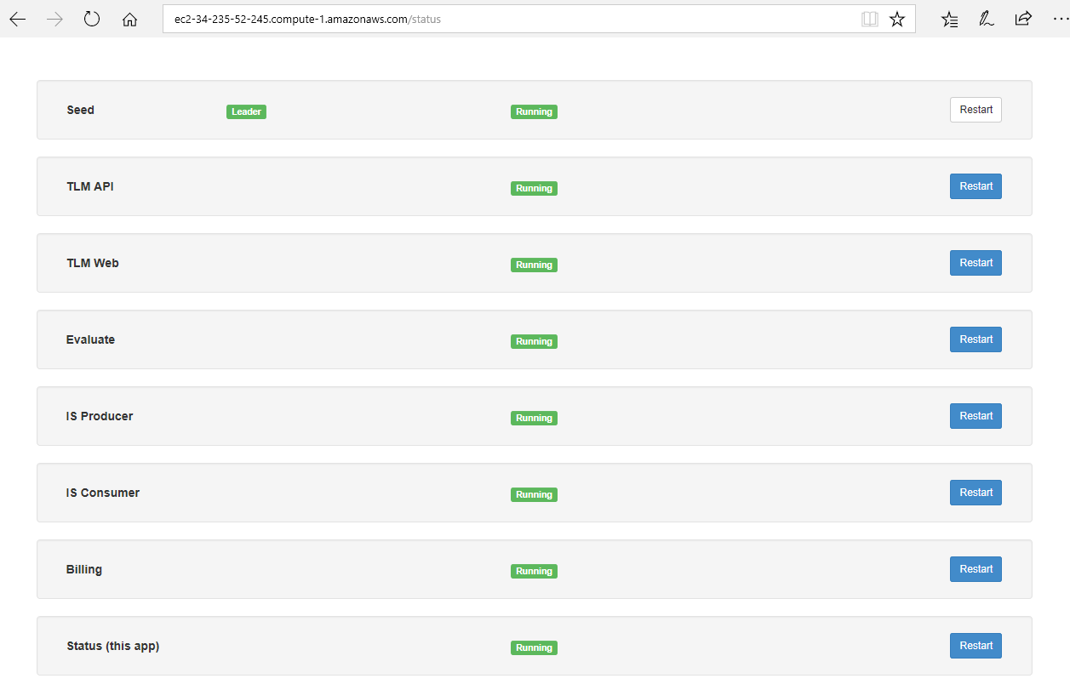

* 1. If the Seed node shows a red 'Stopped' label then you must restart the EC2 instance.
  2. If any of the nodes (expect Seed) show a red 'Stopped' label then press the associated 'Restart' button.

1. The deployment is successful when all services show a green 'Running' labels.

### Step 5. [Enable Data Streaming](http://docs.aws.amazon.com/connect/latest/adminguide/amazon-connect-instance.html#dataexporting)

Follow the steps in the Amazon Connect documentation to set up data streaming.

### Step 6. [Configure the integration](http://s3.amazonaws.com/Qualtrak/E4AC%20Setup.pdf)

Follow the steps in the Qualrak Solutions documentation to complete configuration tasks.

## Best Practices Using Evaluate for Amazon Connect on AWS

Please follow these recommended best practices:

* Configure your RDS MSSQL Db Retention to period to at least 7 days.
* Configure a maintenance window for your RDS MSSQL Db which is outside of your normal working day.
* Before you perform an upgrade to a new release, make create a backup of your RDS MSSQL Db
* Configure your new S3 bucket for Replication to another Region
* Configure your new S3 bucket with Server Side Encrypted (SSE-S3), and AES-256 as a minimum.

## FAQ

**Q.** You have a non-AWS related issues

**A.** For support, please contact Qualtrak's support desk at this address - <http://qualtrak.com/support/>

**Q.** I encountered a CREATE_FAILED error when I launched the Quick Start. What should I do?

**A.** If AWS CloudFormation fails to create the stack, we recommend that you relaunch the template with **Rollback on failure** set to **No**. (This setting is under **Advanced** in the AWS CloudFormation console, **Options** page.) With this setting, the stack’s state will be retained and the instance will be left running, so you can troubleshoot the issue. (You'll want to look at the log files in %ProgramFiles%\Amazon\EC2ConfigService and C:\cfn\log.)

**Important** When you set **Rollback on failure** to **No**, you’ll continue to incur AWS charges for this stack. Please make sure to delete the stack when you’ve finished troubleshooting.

For additional information, see [Troubleshooting AWS CloudFormation](https://docs.aws.amazon.com/AWSCloudFormation/latest/UserGuide/troubleshooting.html) on the AWS website or contact us on the [AWS Quick Start Discussion Forum](https://forums.aws.amazon.com/forum.jspa?forumID=178).

**Q.** I encountered a size limitation error when I deployed the AWS Cloudformation templates.

**A.** We recommend that you launch the Quick Start templates from the location we’ve provided or from another S3 bucket. If you deploy the templates from a local copy on your computer or from a non-S3 location, you might encounter template size limitations when you create the stack. For more information about AWS CloudFormation limits, see the [AWS documentation](http://docs.aws.amazon.com/AWSCloudFormation/latest/UserGuide/cloudformation-limits.html).

## Additional Resources

**AWS services**

* Amazon EC2  
  <https://docs.aws.amazon.com/AWSEC2/latest/WindowsGuide/>
* AWS CloudFormation  
  <https://aws.amazon.com/documentation/cloudformation/>
* Amazon VPC  
  <https://aws.amazon.com/documentation/vpc/>
* Amazon EBS

<http://docs.aws.amazon.com/AWSEC2/latest/UserGuide/AmazonEBS.html>

**Evaluate for Amazon Connect**

* Setup up **Evaluate for Amazon Connect**

<http://s3.amazonaws.com/Qualtrak/E4AC%20Setup.pdf>

* Getting Started

<http://e4ac.s3.amazonaws.com/QuickStartGuide.pdf>

**Quick Start reference deployments**

* AWS Quick Start home page  
  <https://aws.amazon.com/quickstart/>

## Send Us Feedback

You can visit our [GitHub repository](https://github.com/aws-quickstart/tbd) to download the templates and scripts for this Quick Start, to post your comments, and to share your customizations with others.

## Document Revisions

|  |  |  |
| --- | --- | --- |
| Date | Change | In sections |
| November 2017 | Initial publication | — |

© 2017, Amazon Web Services, Inc. or its affiliates, Qualtrak Solutions Ltd. All rights reserved.

**Notices**

This document is provided for informational purposes only. It represents AWS’s current product offerings and practices as of the date of issue of this document, which are subject to change without notice. Customers are responsible for making their own independent assessment of the information in this document and any use of AWS’s products or services, each of which is provided “as is” without warranty of any kind, whether express or implied. This document does not create any warranties, representations, contractual commitments, conditions or assurances from AWS, its affiliates, suppliers or licensors. The responsibilities and liabilities of AWS to its customers are controlled by AWS agreements, and this document is not part of, nor does it modify, any agreement between AWS and its customers.

The software included with this paper is licensed under the Apache License, Version 2.0 (the "License"). You may not use this file except in compliance with the License. A copy of the License is located at <http://aws.amazon.com/apache2.0/> or in the "license" file accompanying this file. This code is distributed on an "AS IS" BASIS, WITHOUT WARRANTIES OR CONDITIONS OF ANY KIND, either express or implied. See the License for the specific language governing permissions and limitations under the License.